The WIID Dataset is a dataset that contains tons of information related to economic statistics of different nations in different years. Some of the economic statistics include income, Gini coefficient, spending, and consumption. I think this dataset can be explained in 4 key graphs.

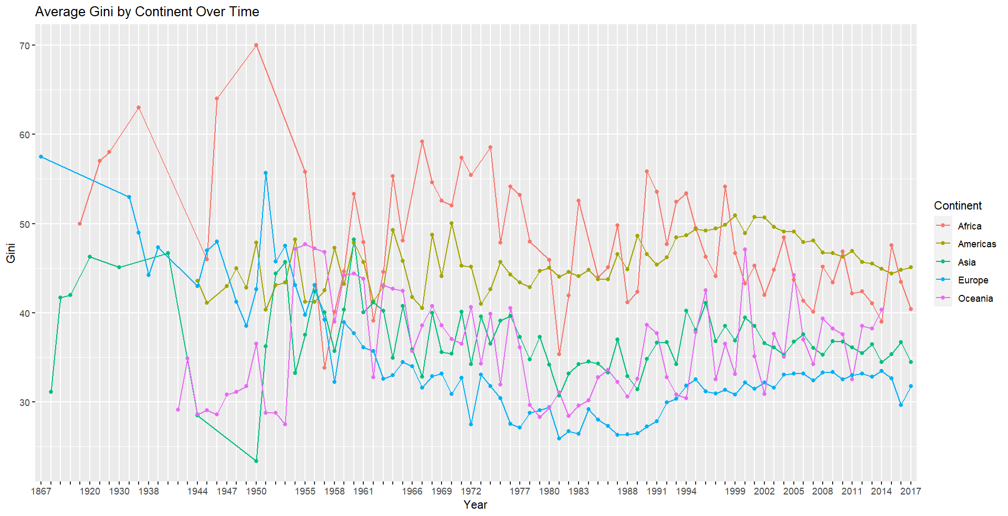

Starting with Graph 2 (Graph 1 is better suited for the end), we can see how income inequality exists in every continent. The higher the Gini, the more unequal the income is distributed. There are some clear trends that can be seen over time with the graph. Europe appears to steadily decrease in Gini over time (essentially grow more equal in terms of income). Same occurrence with Africa. The Americas, Oceania, and Asia, however, seem to all stagnate in their Gini coefficients. I don’t know why this is, but it is an interesting insight.

I chose to go with this type of graph because it shows the longitudinal data related to how the big regions of the world changed in terms of Gini. Gini was an important attribute in the dataset that almost every country had a data point for, so I would be remised to leave this figure out when explaining this dataset. I also used continents as the distinguishing factor for the different lines rather than countries or even subregions as to keep the graph neat. There are just too many nations and subregions that the graph would simply get too messy with them all in it.

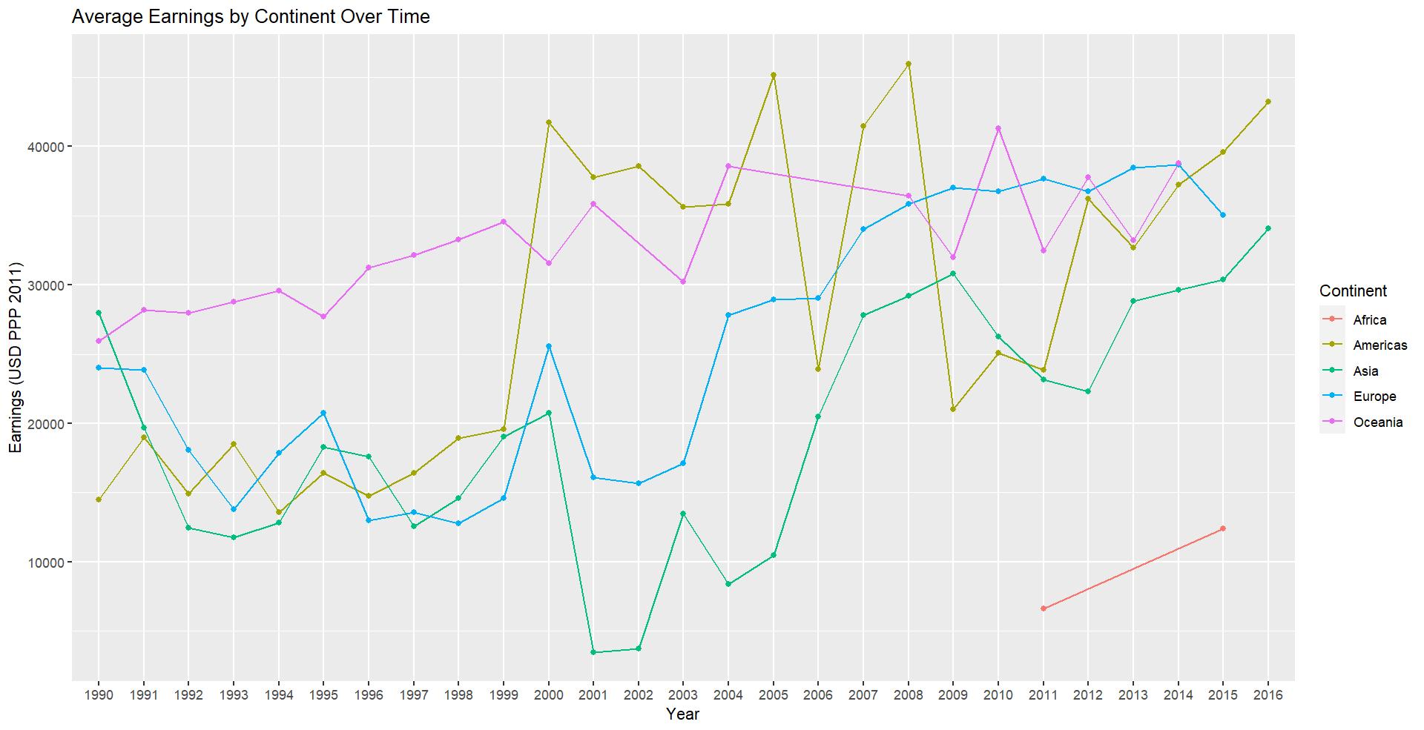

Looking at Graph 3, I look at how earnings change over time for different continents. There is a whole list of economic factors to choose from in the dataset but earning appeared to be one of the more prevalent ones. I went to graph earnings because of that. Essentially, all the continents rose in earnings over the past 3 decades.

There are many economic factors in the dataset. I believe it would have been fine to go with any of them, but I had to choose one. The most important thing people imagine about a country is how well off the individuals are in it. Earnings is the economic metric to show this off. All the other economic factors like consumption and spending follow a similar pattern so there would be no reason to include graphs of those. I also had to separate the lines by continent because it would be too cluttered with individual countries or subregions.

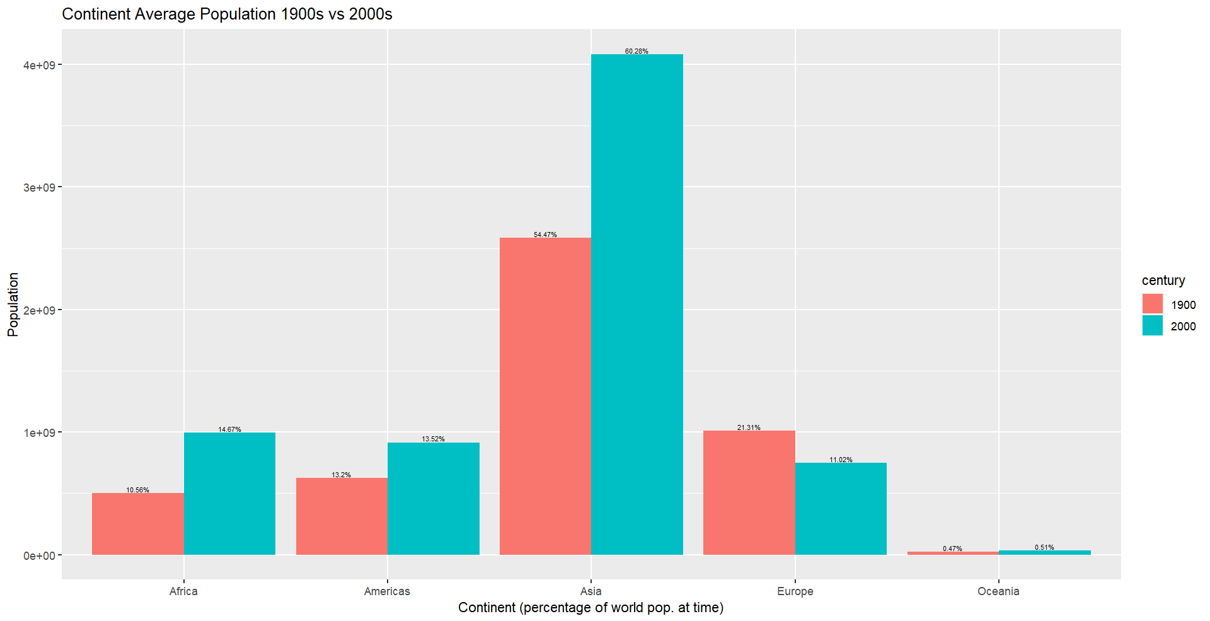

In this graph, I look at how the population of continents changed over the centuries. I had a limited amount of data for each country’s population. I could use this to generate the population proportions for every continent by century to show how the dynamics of the world have changed over time. I think this is an important metric for the dataset because this is a massive change that every continent sees over time. I didn’t have much data to show for this, so I split it up into century based periods.

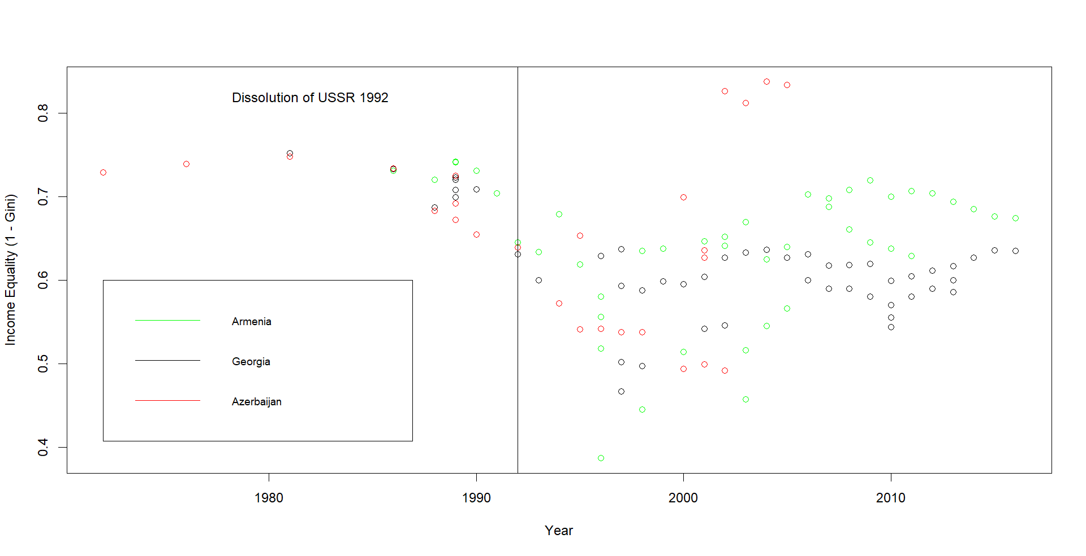

This is the final graph that I would like to look at. This shows how the income equality of different countries in the Caucuses changed over time. I added a line to show when the Soviet Union fell apart to show how major geopolitical events can affect individual countries widely. This doesn’t explain the whole dataset directly, but I think it’s important to show some data related to individual countries to show ho major events in the world like the dissolution of the USSR can have very wide-ranging impacts on different nations. Similar outcomes like this can be seen in other nations when scouring the data.